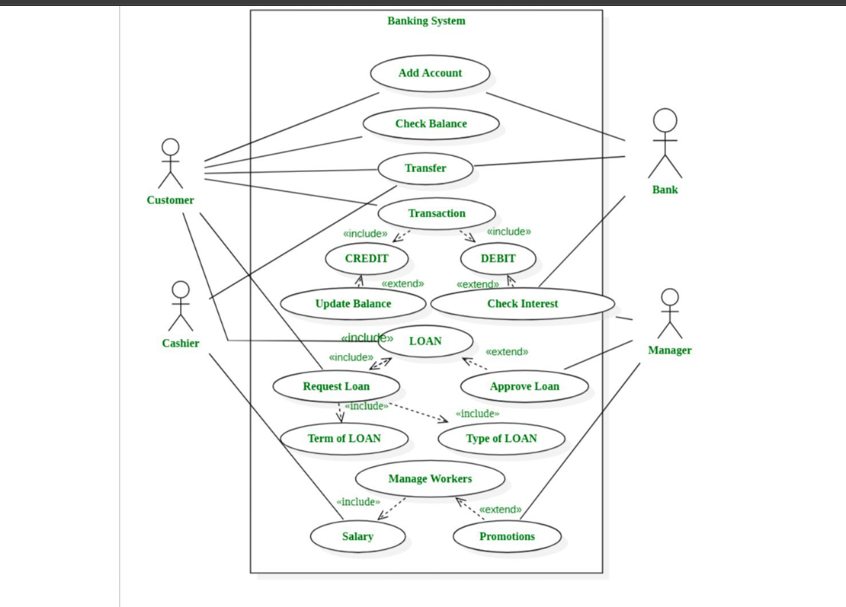

Use Case: Automated Banking System
System Name:
Automated Banking System
Actors:
- Customer
- Cashier
- Bank System
- Manager
Brief Description:
The Automated Banking System enables customers to perform banking operations such as account creation, balance enquiry, fund transfer, transactions, loan processing, and EMI management. The system automates interest calculation, EMI deduction, and balance updates while allowing managers to approve loans and manage employees.
Use Case Descriptions:
1. Add Account

Actor: Customer, Bank System

Description: Customer creates a new bank account using the automated system.
2. Check Balance
Actor: Customer
Description: Customer checks current account balance automatically.
3. Transfer
Actor: Customer, Bank System
Description: Transfers money between accounts securely.
4. Transaction
Actor: Customer, Cashier
Includes: Credit, Debit
Description: Performs automated financial transactions.
a) Credit (Include)
Adds money to account
Extends: Update Balance
b) Debit (Include)
Withdraws money from account
Extends: Check Interest
5. Update Balance
Actor: Bank System
Description: Automatically updates balance after every transaction.
6. Check Interest
Actor: Bank System, Manager
Description: Calculates interest on savings and loans.
7. Loan
Actor: Customer, Cashier, Manager
Includes: Request Loan, EMI Calculation
Extends: Approve Loan
8. Request Loan
Actor: Customer
Includes:
Term of Loan
Type of Loan
Description: Customer applies for a loan through the system.
9. Approve Loan
Actor: Manager
Description: Manager approves or rejects loan requests.
10. EMI (Equated Monthly Installment)
Actor: Bank System, Customer
Includes: EMI Calculation, EMI Deduction
Description: Automatically calculates and manages loan repayment installments.
a) EMI Calculation (Include)
Calculates EMI based on loan amount, interest rate, and loan term.
b) EMI Deduction (Include)
Automatically deducts EMI from customer’s account every month.
11. Term of Loan
Actor: Customer
Description: Specifies the duration of the loan.
12. Type of Loan
Actor: Customer
Description: Selects loan type (Home, Education, Personal, Vehicle).
13. Manage Workers
Actor: Manager
Includes: Salary
Extends: Promotions
14. Salary
Actor: Manager
Description: Manages employee salary details.
15. Promotions
Actor: Manager
Description: Handles employee promotions.
Conclusion:
The Automated Banking System improves efficiency by automating transactions, interest calculation, loan approval, and EMI processing. The inclusion of EMI ensures accurate and timely loan repayments while reducing manual effort and errors.

CLASS DIAGRAM

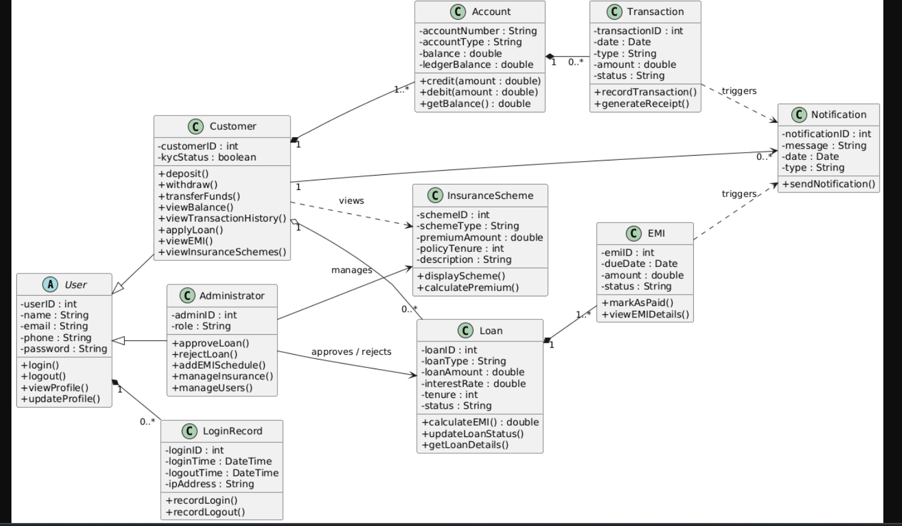

Class Diagram Description – Automated Banking System
The class diagram represents the structural design of the Automated Banking System (ABS). It shows the system classes, their attributes, methods, and relationships between them.
User (Abstract Class)
The User class acts as the parent class for all system users. It contains common attributes and operations shared by customers and administrators.
Attributes:
- userID
- name
- email
- phone
- password
Methods:
- login()
- logout()
- viewProfile()
- updateProfile()
This class is inherited by Customer and Administrator. It is also associated with LoginRecord to maintain login history.

Customer
The Customer class represents bank customers who perform banking and loan-related activities.
Attributes:
- customerID
- kycStatus
Methods:
- deposit()
- withdraw()
- transferFunds()
- viewBalance()
- viewTransactionHistory()
- applyLoan()
- viewEMI()
- viewInsuranceSchemes()
A customer owns accounts, applies for loans, receives notifications, and views insurance schemes.

Administrator
The Administrator class represents authorized personnel responsible for managing system operations.
Attributes:
- adminID
- role
Methods:
- approveLoan()
- rejectLoan()
- addEMISchedule()
- manageInsurance()
- manageUsers()
The administrator manages insurance schemes and approves or rejects loan applications.

Account
The Account class represents a bank account owned by a customer.
Attributes:
- accountNumber
- accountType
- balance
- ledgerBalance
Methods:
- credit()
- debit()
- getBalance()
An account records financial transactions performed by the customer.

Transaction
The Transaction class represents banking operations such as deposits, withdrawals, and fund transfers.
Attributes:
- transactionID
- date
- type
- amount
- status
Methods:
- recordTransaction()
- generateReceipt()
Transactions are linked to accounts and can trigger notifications.

Loan
The Loan class represents loan details requested by a customer.
Attributes:
- loanID
- loanType
- loanAmount
- interestRate
- tenure
- status
Methods:
- calculateEMI()
- updateLoanStatus()
- getLoanDetails()
A loan is associated with a customer and contains multiple EMI records. It can be approved or rejected by an administrator.

EMI
The EMI class represents installment payments related to a loan.
Attributes:
- emiID
- dueDate
- amount
- status
Methods:
- markAsPaid()
- viewEMIDetails()
Each EMI belongs to a loan and may trigger a notification for upcoming payments.

InsuranceScheme
The InsuranceScheme class represents available insurance plans such as term and health insurance.
Attributes:
- schemeID
- schemeType
- premiumAmount
- policyTenure
- description
Methods:
- displayScheme()
- calculatePremium()
Insurance schemes are managed by administrators and viewed by customers.

LoginRecord
The LoginRecord class stores login activity details of users.
Attributes:
- loginID
- loginTime
- logoutTime
- ipAddress
Methods:
- recordLogin()
- recordLogout()
It helps maintain login history and system security.

Notification
The Notification class represents alerts sent to customers.
Attributes:
- notificationID
- message
- date
- type
Methods:
- sendNotification()
Notifications are triggered by transactions and EMI events and are sent to customers.

